Social Media Content

Best Practices:
- Tag the following;
  - On Facebook, tag Zero Fatalities Nevada
  - On Twitter, tag @DriveSafeNV
  - On Instagram, tag @zerofatalitiesnv
- Use the following hashtags: #DriveSafeNV #ZeroFatalites #PedestrianSafety

Pedestrian Safety Content Ideas:
- Content: Although pedestrians have the right-of-way in a crosswalk and at intersections, vehicles don't always stop. Before you step off the curb, make certain cars in both directions have stopped. Don't put yourself or anyone else in the position for a potential crash.
Asset: Use photo titled Pedestrian 2
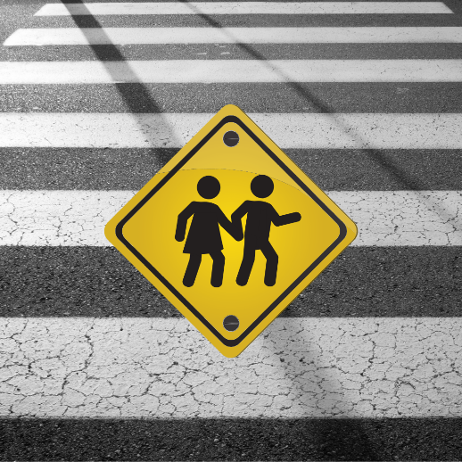

- Content:
While crossing the street, you should:
A. always keep watching for traffic
B. try to make eye contact with any drivers
C. both of the above
Asset: Use photo titled Pedestrian 1
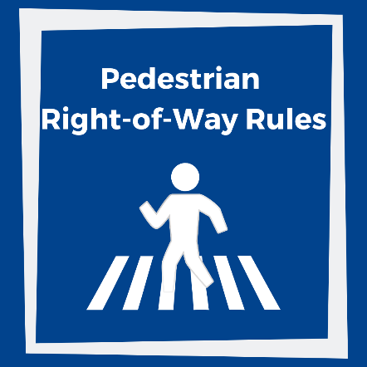

- Content: As a pedestrian, pay attention to where you’re going—distracted walking can be just as dangerous as distracted driving. For more tips visit: https://bit.ly/2pBt8jZ
Asset: Use photo titled Pedestrian 3
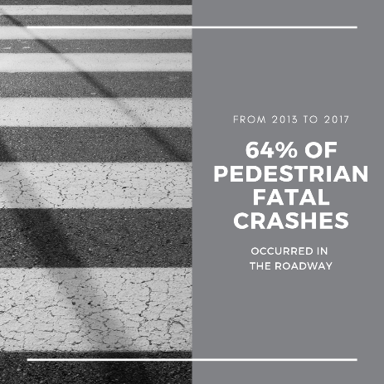

- Content: Every pedestrian fatal crash is preventable. Motorists, know the law, yield to pedestrians, and share the road. Pedestrians, be visible, use crosswalks, and be predictable.
Asset: Use photo titled Pedestrian 6
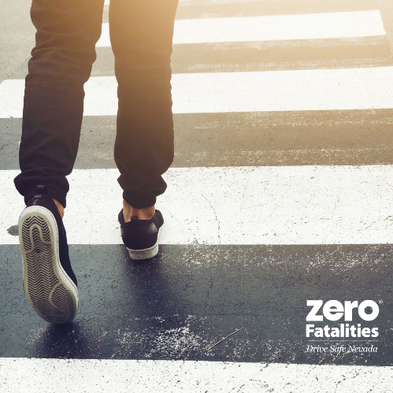

- Content: A pedestrian died every 88 minutes in 2017, in the United States. Learn more about the importance of pedestrian safety at www.zerofatalitiesnv.com.
Asset: Use photo titled Pedestrian 5
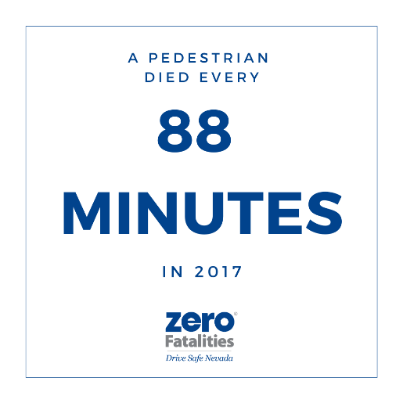

- Content: Before crossing an intersection, look left, right, and left again for oncoming or turning traffic. Establish eye contact with drivers who slow down or stop to ensure the driver is yielding the right-of-way to you.
Asset: Use photo titled Pedestrian 6
