Social Media Content

Best Practices:
- Tag the following;
  - On Facebook, tag Zero Fatalities Nevada
  - On Twitter, tag @DriveSafeNV
  - On Instagram, tag @zerofatalitiesnv
- Use the following hashtags: #DriveSafeNV #ZeroFatalites

Impaired Content Ideas:
- Content: #ProTip: Take care of your fellow Nevadans. If you know someone is about to drive impaired, take their keys and help them make other arrangements to get home safely.
Asset: Use photo titled Impaired 4
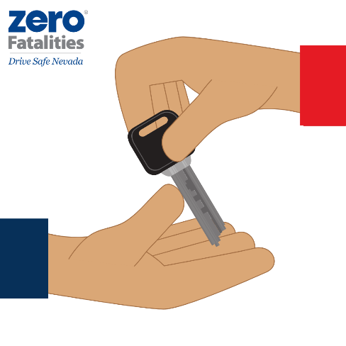

- Content: Under Nevada's Implied Consent Law, if an officer suspects you are driving under the influence, you will be asked to take a blood or breath test. If you fail to submit to these tests, your license permit or privilege to drive will be revoked.
- Asset: Use photo titled Impaired 1 or Impaired 5
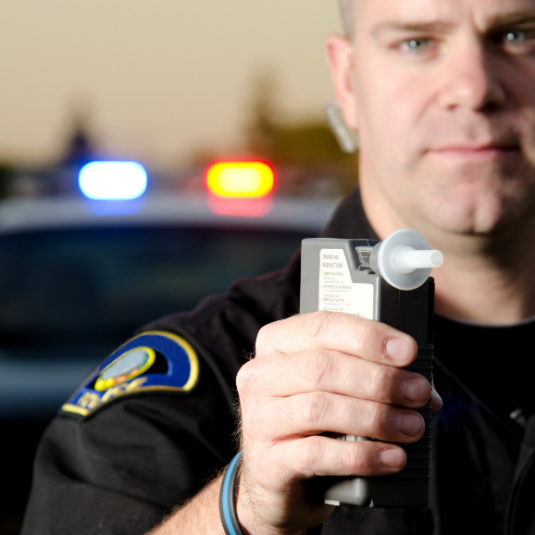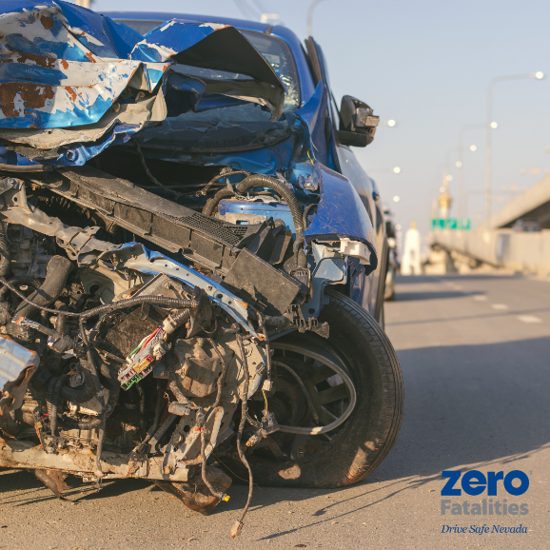

- Content: You can report a suspected drunk driver or any highway emergency on a cell phone anywhere in Nevada by dialing *NHP (*647).
Asset: Impaired 1 or Impaired 5

- Content: Of the 1,147 children killed in traffic crashes in 2017, 19% were killed in alcohol-impaired-driving crashes. Drive sober, Nevadans. Don't kill a dream.
Asset: Impaired 3
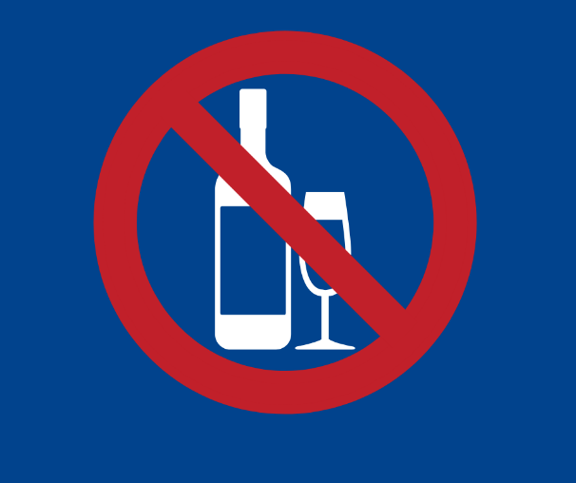

- Content: Impaired drivers can’t accurately assess their own impairment – which is why no one should drive after using any impairing substances. Remember: If you feel different, you drive different.
Asset: Use photo titled Impaired 2
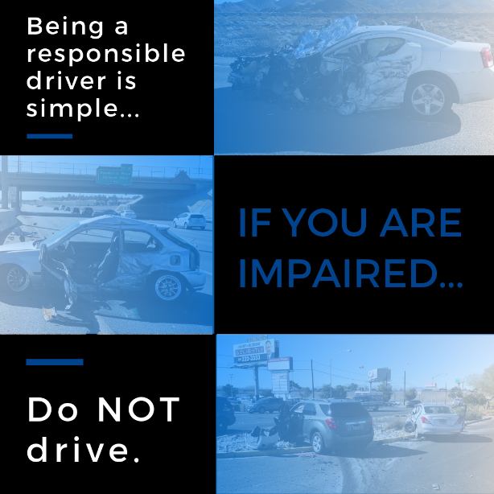

- Content: Those who drive under the influence of alcohol or drugs, whether obtained legally or illegally, pose a danger to themselves, their passengers, and others on our roadways. We can all save lives by making smarter choices. So please, be a responsible driver and don't drive impaired.
- Asset: Use photo titled Impaired 2

