Social Media Content
*Right click photos and click “save as picture” to use assets

Best Practices:
- Tag the following;
  - On Facebook, tag Zero Fatalities Nevada
  - On Twitter, tag @DriveSafeNV
  - On Instagram, tag @zerofatalitiesnv
- Use the following hashtags: #DriveSafeNV #ZeroFatalites

Motorcycle Content Ideas:
- Content: If you are coming up behind a motorcycle, slow down sooner than you would for another vehicle. Leave plenty of space!
Asset:

- Content: Please look twice and be aware of motorcyclists. We all know someone or have loved ones who are riders.
Asset:
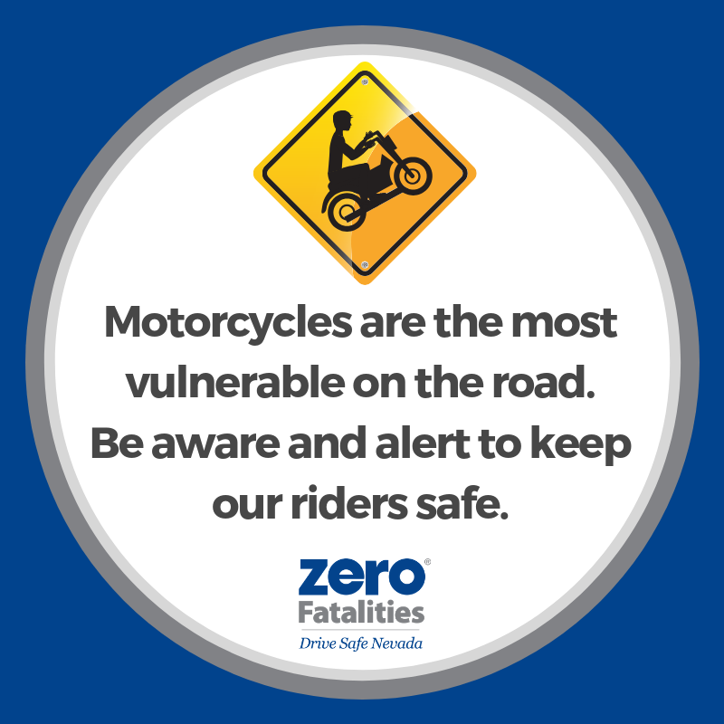

- Content: 54 motorcyclists were killed on Nevada roads in 2017. Look twice before you turn. https://nevadarider.com
Asset:
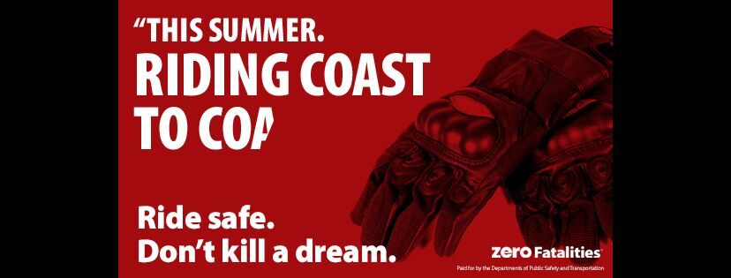

- Content: Riders! Please remember that lane splitting and riding between vehicles occupying adjacent traffic lanes is NOT permitted in the state of Nevada.
Asset:

- Content: Motorcycle riders are more than 27X more likely than passenger car occupants to die in motor vehicle traffic crashes.
Asset:

