Social Media Content
*Right click photos and click “save as picture” to use assets

Best Practices:
- Tag the following;
  - On Facebook, tag Zero Fatalities Nevada
  - On Twitter, tag @DriveSafeNV
  - On Instagram, tag @zerofatalitiesnv
- Use the following hashtags: #DriveSafeNV #ZeroFatalites

Distracted Content Ideas:
- Content: Distracted driving is ANY activity that takes your focus off the road. If driving doesn't have your full attention, you are not driving safely.
Asset:
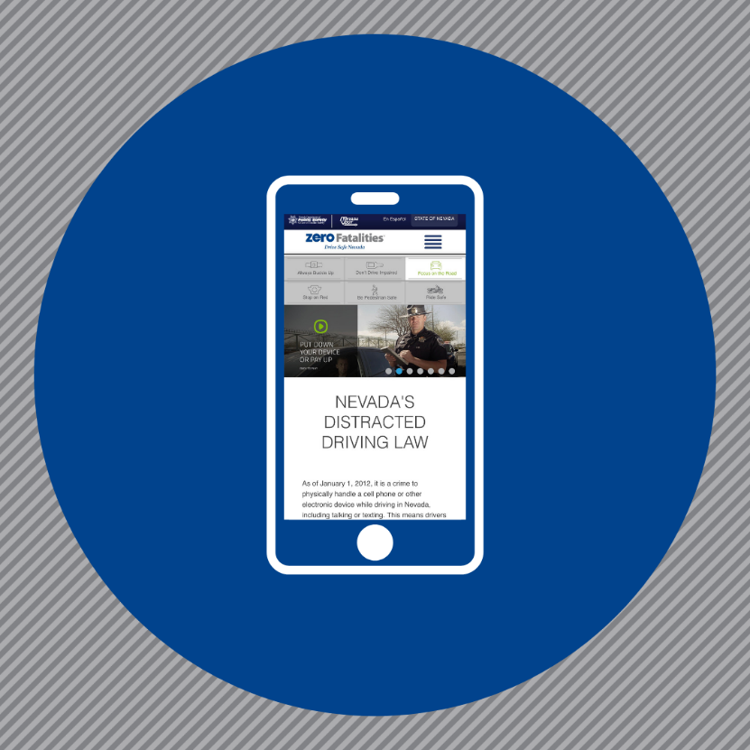

- Content: Driving distracted is NEVER worth the risk so pay attention, keep your eyes on the road, and your hands on the wheel.
Asset:
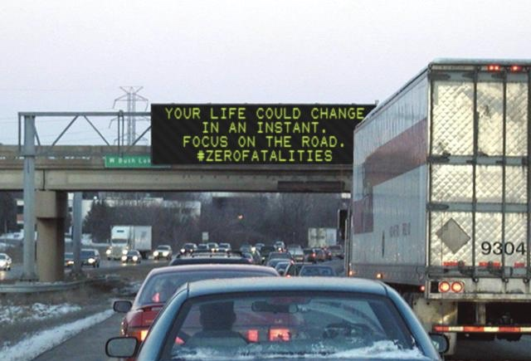

- Content: Distraction occurs when a driver's attention and focus is taken off the road. What distracts you the most while driving? Read more on Nevada’s distracted driving laws here: https://bit.ly/2HgPIXJ
Asset:
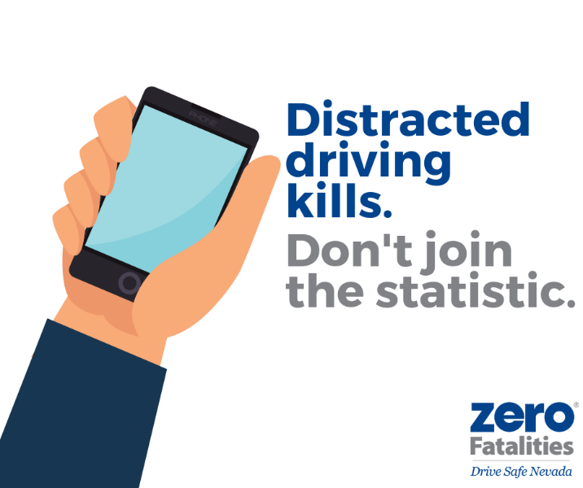

- Content: Do selfies count as distracted driving? The answer is YES! Distracted driving is anything that takes your attention away from driving. Keep your eyes on the road, hands on the wheel, and stay focused.
Asset:
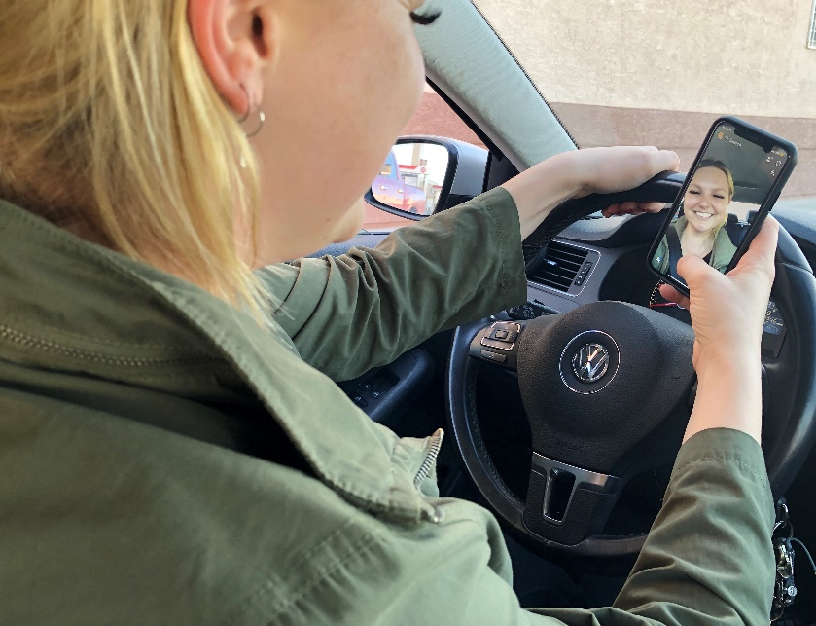

- Content:
Which is allowed while driving?
A. Putting on makeup
B. Using your cell phone
C. Neither
D. OF COURSE NEITHER!
Asset:
