Social Media Content
*Right click photos and click “save as picture” to use assets

Best Practices:
- Tag the following;
  - On Facebook, tag Zero Fatalities Nevada
  - On Twitter, tag @DriveSafeNV
  - On Instagram, tag @zerofatalitiesnv
- Use the following hashtags: #DriveSafeNV #ZeroFatalites

Occupant Protection Content Ideas:
- Content: Always wear your seat belt correctly. Wearing BOTH your lap and shoulder belt is the best line of defense. The lap belt and shoulder belt are secured across the hip bones, across the chest, and positioned at mid-shoulder.
Asset:
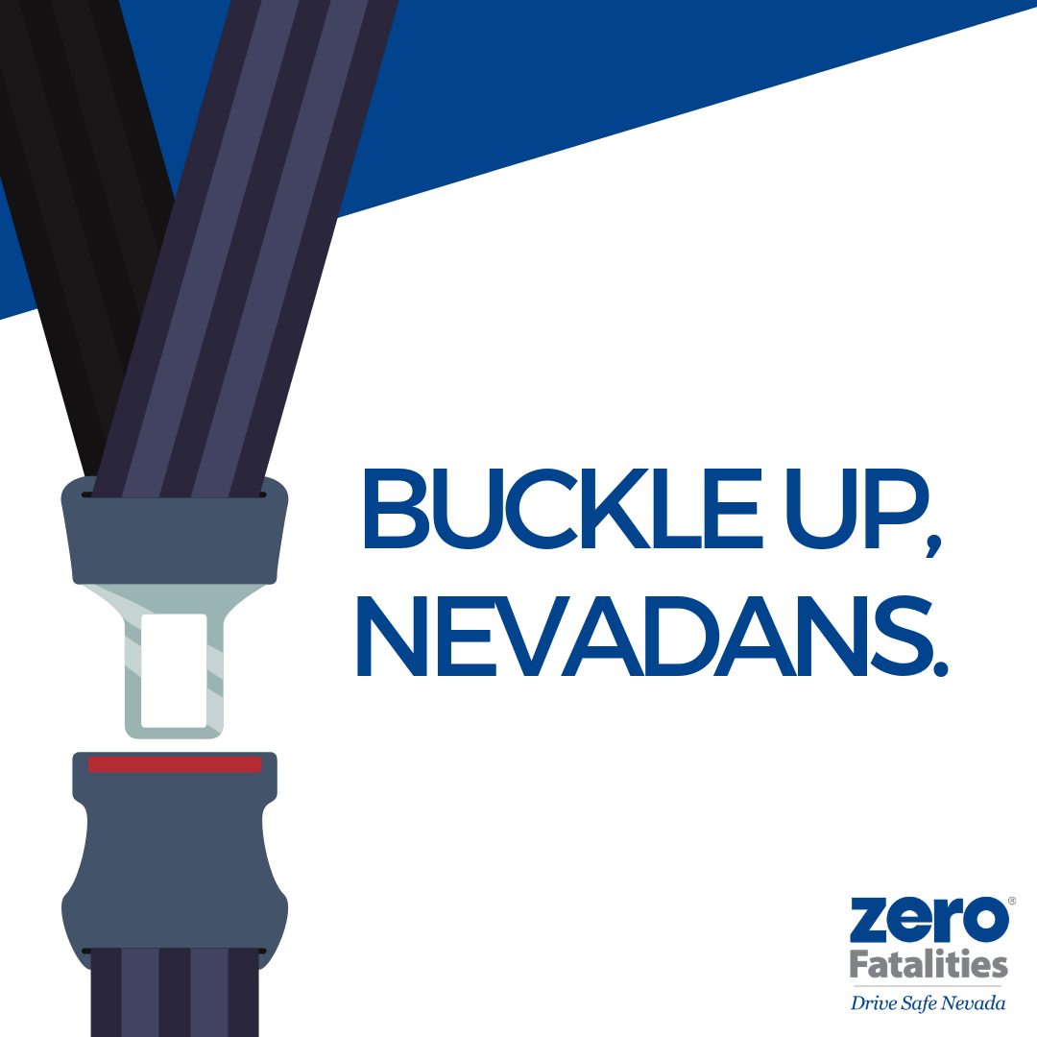

- Content: Pro tip: Air bags are designed to work with seat belts, not replace them.
Asset:

- Content: You are 75% more likely to be killed in a rollover crash without a seat belt. Make sure you buckle up, Nevadans.
Asset:
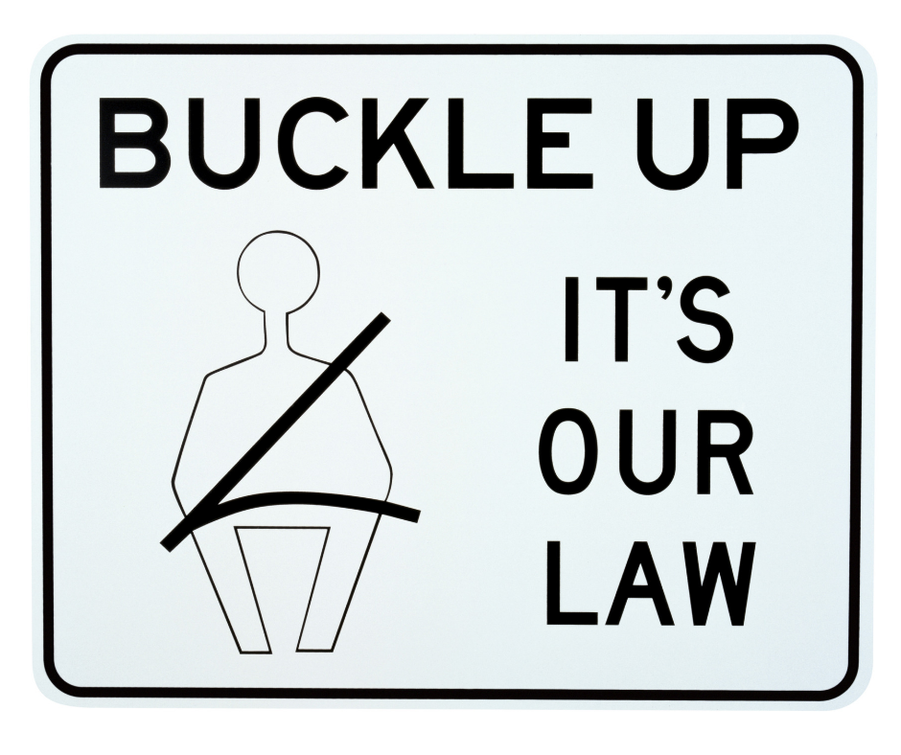

- Content: Men ages 26 to 35 years old comprise the largest number of victims of unbelted-occupant fatal and serious injury crashes from 2013 to 2017. Please buckle up, Nevadans.
Asset:
